Our ref: 5397183

18 November 2014

Mr S Murray
Regional Manager
NSW Planning & Environment
Locked Bag 9022
GRAFTON NSW 2460

Dear Mr Murray

Planning Proposal – Bonville Large Lot Residential Investigation Area

Please find enclosed a revised Planning Proposal in relation to a request for a Gateway Determination. The original request was forwarded to Planning and Environment (P&E) on 13 October 2014 and is being assessed by Mr Paul Garnett.

This revised Planning Proposal addresses P&E’s request for additional information (emailed to Council on 28 October 2014).

If you require any further information regarding this matter, please contact me on 6648 4654.

Yours faithfully
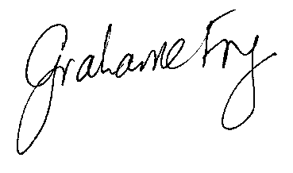
Grahame Fry
Sustainable Planning Officer

GCF:kdl

Encl.

